**Working with Git HUB**

In real time working with Git so simple and very easy but most the time everyone faces some difficulties in understanding the scenario and fails to use it. So in this document I will be explaining how to work with GitHub by creating the new account in the Github.com according to my knowledge.

To Create a Git Hub account please follow the link.

<https://github.com/>



Please provide the following credentials and sign up the account.

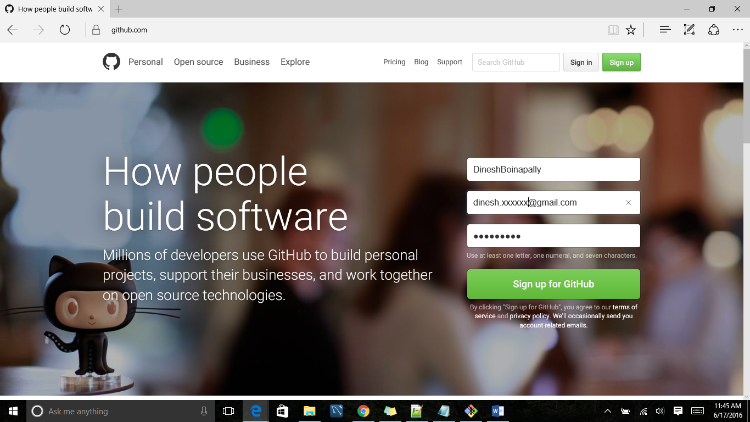

Once you hit the signup button you are account will be created and looks very much similar to the below image.

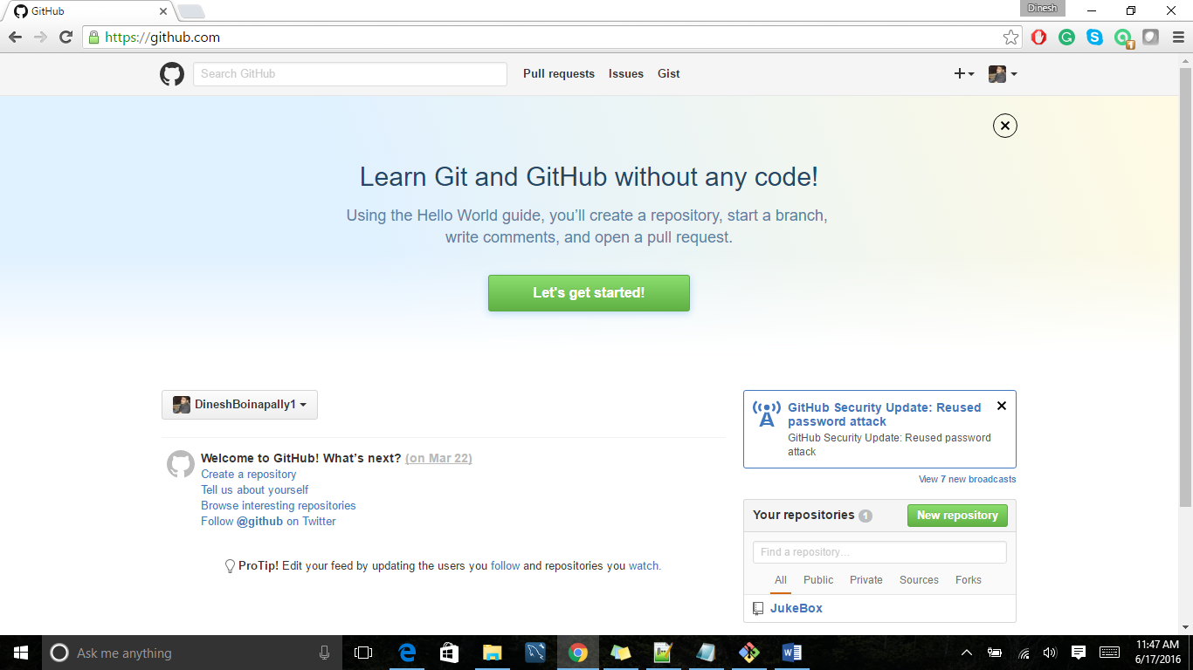

Now if we observe the home page that is displayed right after sign up we can find a “New repository” button on the right hand side of the home page.

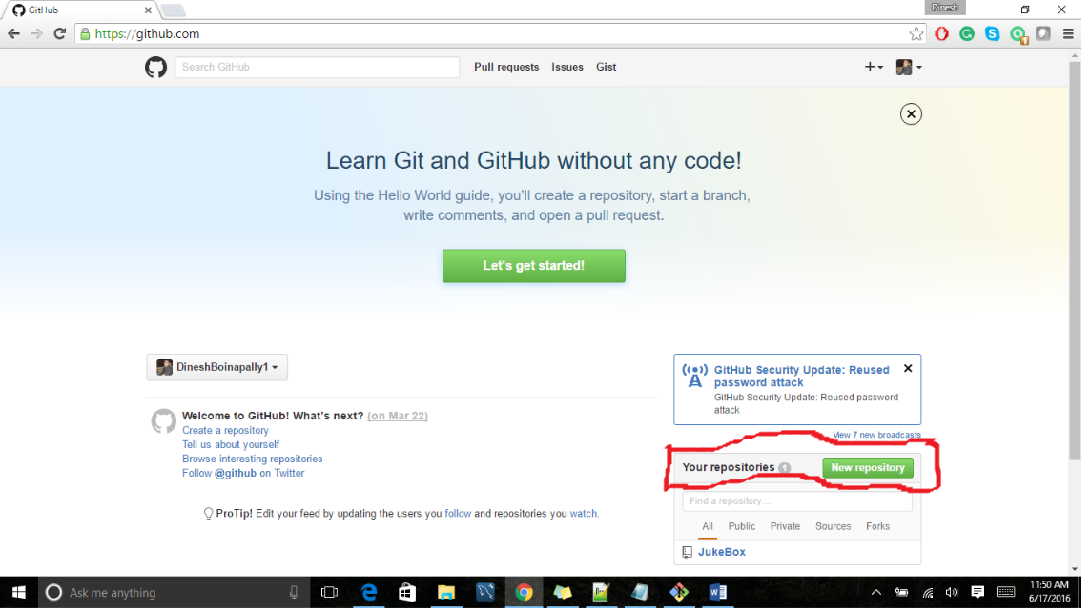

Now please hit the “New repository” and create it.

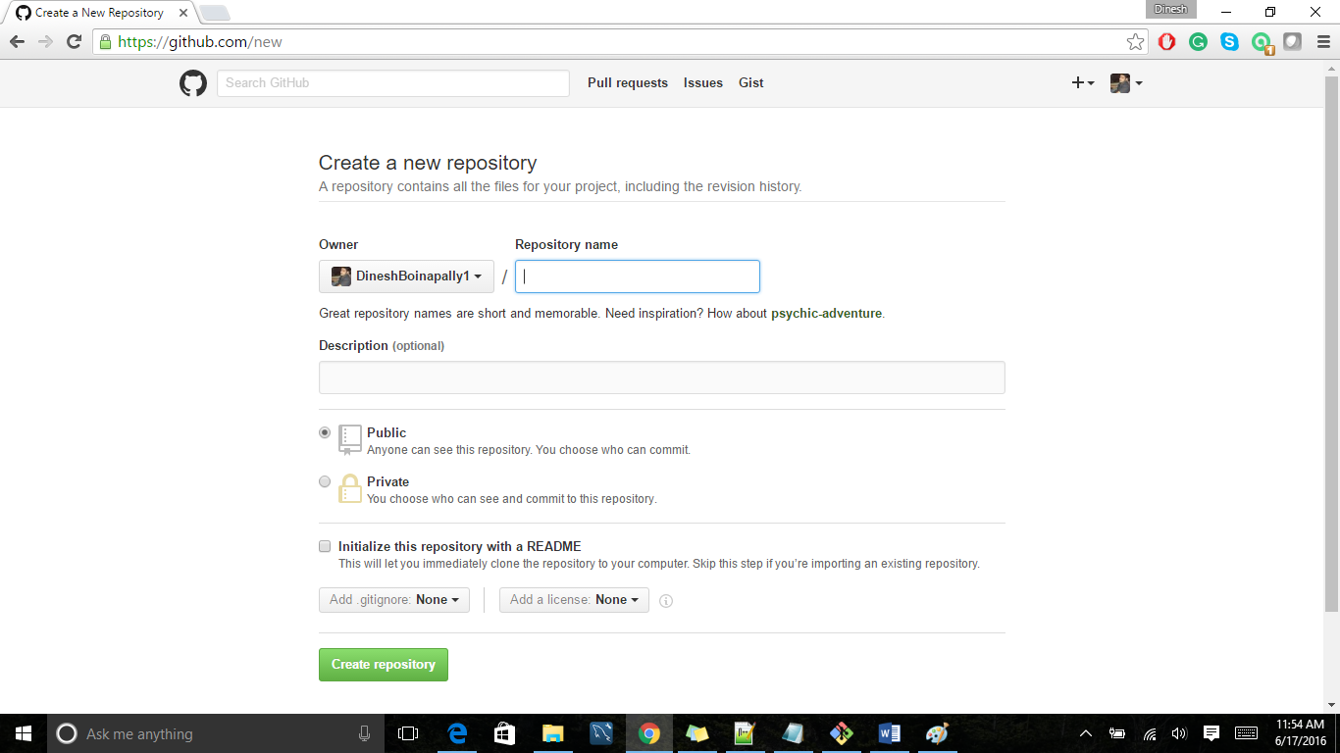

Please mention the repository name of your own choice, Description, and also we can have our GitHub account private or public. The only difference between these two is if we select public, it is visible to all, so the beginners can use the project or code of ours as a reference for their own project and the best thing is we will be most popular in the market where as private is simply a private account, most of the time private account will be used by office people and one more option to be choose is Initialize a “Readme.txt” file, even this is also optional one.

In my example I creating “JukeBox” as my repository name and selected it to be public account so any one can see this document. Once we are done it, the repository will be created and will be added to the “Your Repository” list.

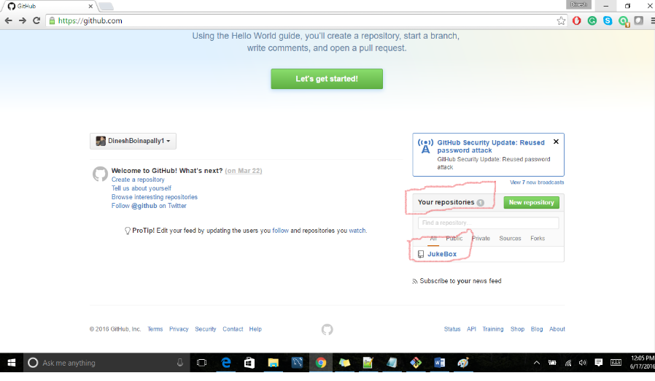

Till we have done setting up the account in online. Now we have to install Git in our local system(Desktop/Laptop). To install Git, please follow the below link.

<https://git-scm.com/downloads>

Now let’s start working with the repository which we have created, for better understanding let’s discuss it Step – By – Step.

Step1:

* Create a folder in our local system(Desktop/Laptop) with some name in any folder.
* Right Click on the newly created folder and select **Git Bash Here.**
* In my case I named my folder name as “**Repository”**

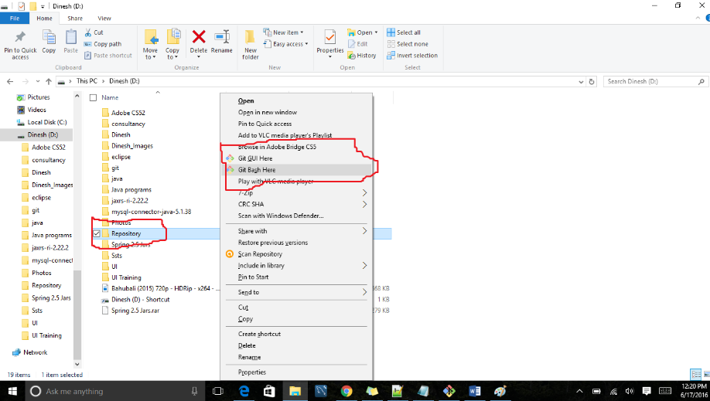

So it will open the Git command prompt. Now use the clone command to get repository which is available in server side to our local system.

Command: git clone <URL>

So what is this <URL>?

* It is the url of the repository, which is available by clicking on the name of the repository “JukeBox” and clicking the clone or download button.

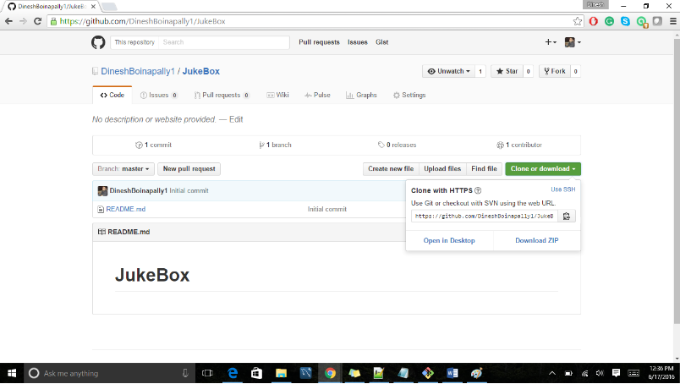

Please copy the link and go to the git command line and paste it.

Once again the command is

git clone https://github.com/DineshBoinapally1/JukeBox.git

Now in our local system the repository will established with the name “JukeBox” inside the folder we created.

Now let’s work with it by adding the sample text file to the repository. Check-in the code will be in two steps.

* First we will add the code file locally
* Second we will push the code to the server side.

Now we have to add some file in our local repository and push them so before doing that we have to go to the “JukeBox” folder.

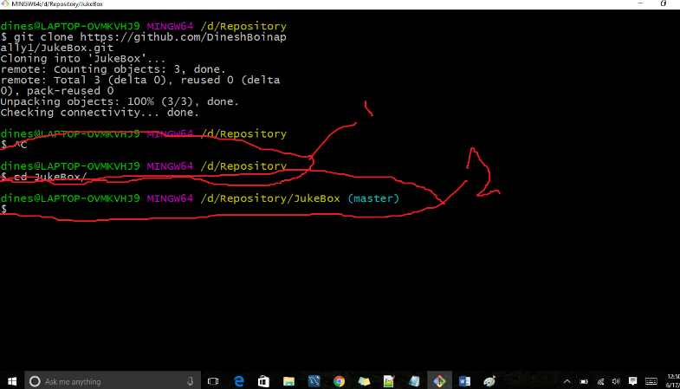

I’m sorry I’m not that good at working with paint but let me explain the above image. For command 1: it is up to the folder which we are created but we have to enter the repository which is there inside the folder. So by entering the command: “cd JukeBox/” the root path will be changed to step ahead and enters the opens the JukeBox folder inside folder which we have created.

Now let’s add a simple text file with name “Hello world”.

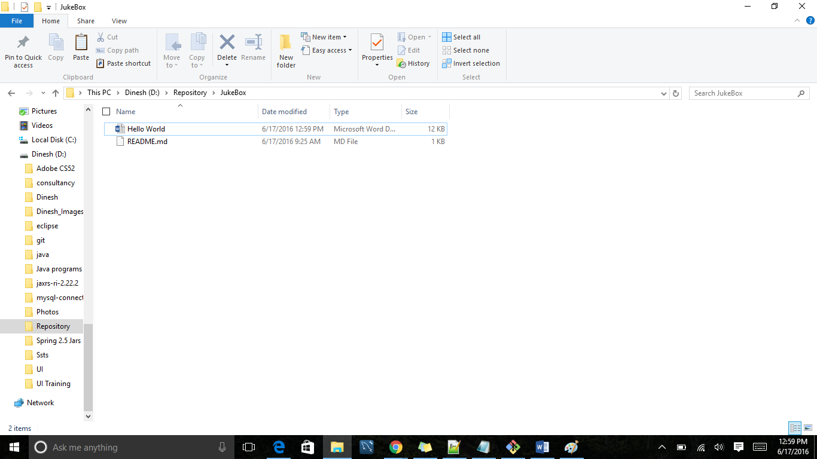

Once after adding the file Let’s go to git command line try to look the status and the command for this

git status

Then it gives the result showing the result that there is a new untracked file added to it also the other information provided by it are

1. on which branch you are in

2. What are all the newly added files

3. what are all the modified file

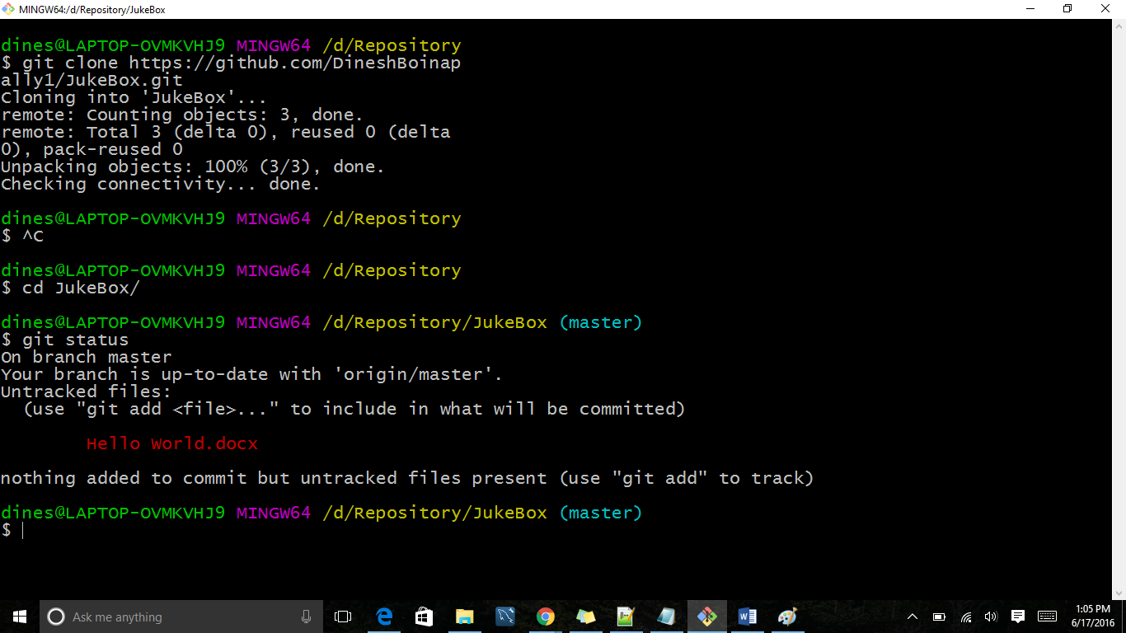

so now we have to add all the files (new/modified) file to our local repository

command for this is:

git add –all

**Note**: here if we want to add some specific files then git add that specific file name.

so this will add all the files to your local repository and now we have to save the files in our local repository. To perform this the command is

git commit -m “Description about the commit we are doing”

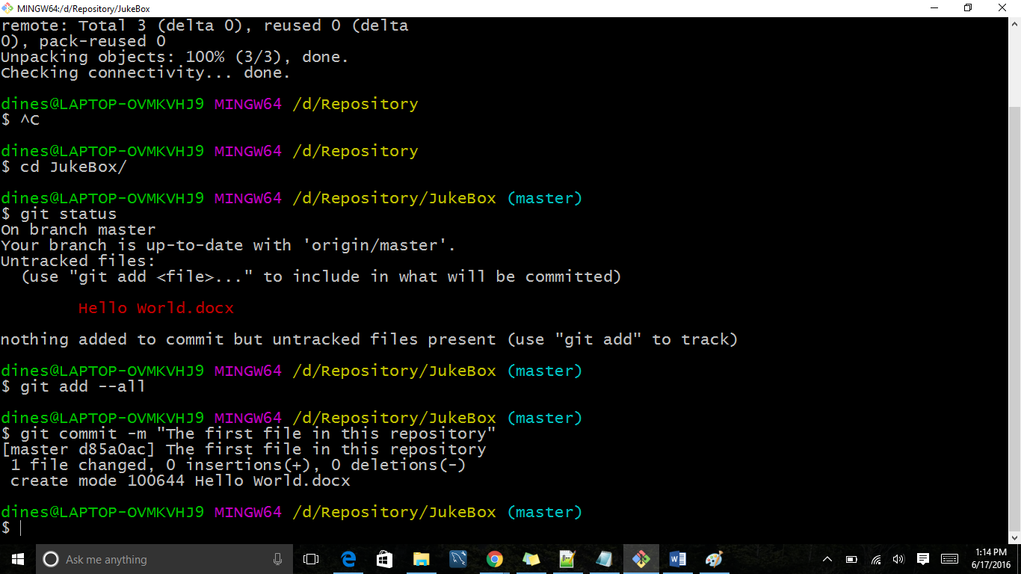

Now comes the role hitting the server and submitting the code. The command for this

git push

This for the first time it asks for username and password so please provide them. So that it will push the file to the server.

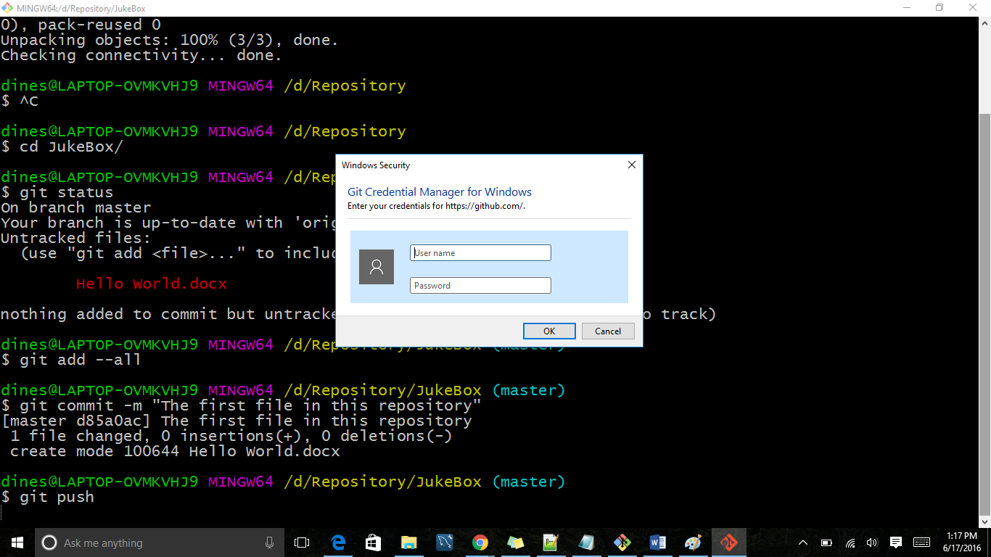

Once the credential is entered the file will be pushed to the server repository.

Here we are pushing the code to the master branch but in real time we will not push this to the master branch. for example

there are two teams but the code is same for both the teams.

1. working on registration code

2. working with login features.

so if these two teams work on one branch conflicts will arise so we will branch the code.

**Branching the code**

Let’s branch this to three departments.

1. Development Team
2. Testing Team
3. Production Team

The command for performing the branches is

git branch branch_name

Ex: git branch development

git branch testing

git branch production

To see how many branches are available in the server the command is

“git branch”

At this point now we are working with master branch and to go to different branch the command is

“git checkout branch_name”

Ex: git checkout development

git checkout testing

git checkout production

Each and every file which is created inside one branch is limited to that particular branch itself and no other branches cannot use until the permissions granted.

“***The Best Flavor of Git is we can have one folder with many braches where as other like SVN, RTC will be having different folders for different branches.”***

Let’s do some exercise on Branches:

git checkout development

add a txt file which we used earlier with some information in it.

then perform the actions like status, add --all, commit -m

Till here we saved the code in our local repository and should push this to server right-----But the problem is we haven't created any branches in server. So let’s do this by this command.

Command: git push -u origin production

so it’s going to save all the files inside the production branch.

One important last command is “PULL”.

Command is: git pull

Why to use this pull:

for example, you and your teammate is working on the code and he is from off shore. he worked during the ni8 and pushed into the server and now we don’t have that code. so after coming to the office we had a message check the code and add few more components. so to update the folder with the code developed by our teammate use "git pull".